**Barak Pinchovski**

[Re’im, Israel](https://goo.gl/maps/sawEnAiojKq) | Mobile: +972544452446 | [barakpinch@gmail.com](mailto:barakpinch@gmail.com) | [LinkedIn Profile](https://www.linkedin.com/in/barakpinch/) | [GitHub Profile](https://github.com/barakpinchovski)

**Brief Timeline Infographic**

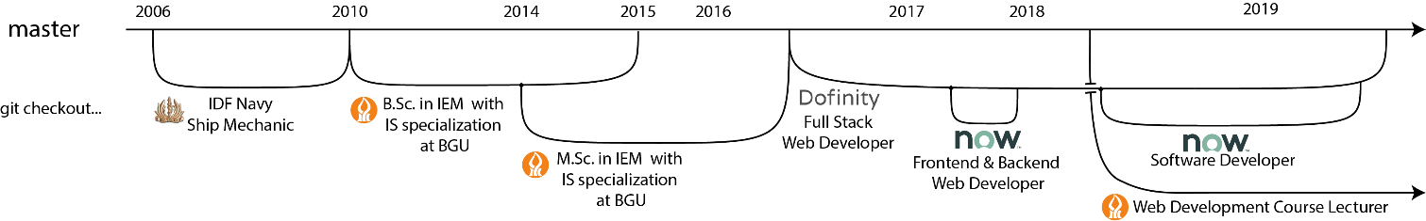

**Current endeavors and work experience:**

|  |  |
| --- | --- |
| 2018 – Today: | Web Development course lecturer at Ben-Gurion University of the Negev.  Developed [Dreamers](https://github.com/barakpinchovski/dreamers) teaching assistant tool (work in progress). |
| 2016 – 2019: | Full Stack Web Developer at [Dofinity - Premium Web Solutions](https://www.dofinity.com/).   * Analyzed, designed and developed small to large Drupal 7 and Drupal 8 web development projects over LAMP stack - on time, scope and budget. * Managed and led small teams of 2 or 3 developers. * Involved in customer support and DevOps engineering. |
| 2018 -2019: | Software Engineer at ServiceNow for an external project of Dofinity.   * Developed new features, wrote tests, fixed bugs and maintained code. * Implemented, developed and tested WCAG 2.0 level AA requirements for EM. * Participated in ServiceNow's 2017 and 2018 ITOM Innovation Days. Registered patent B (see at the bottom) and created a private chrome extension. |
| 2017: | Web Developer at ServiceNow for an external project of Dofinity.   * Implemented WCAG 2.0 level A requirements in ServiceNow ITOM products. * Participated in ServiceNow's 2017 ITOM Innovation Day. Registered patent A. |

**Education:**

|  |  |
| --- | --- |
| 2014 – 2016: | * Meitar Program student for a Master of Science (M.Sc.) degree (with thesis) in IEM with specialization in IS at BGU. Grades average: 87.7. Thesis grade: 95. * Teaching assistant for WEB Development course offered at BGU-IEM department.  Created a [video tutorial](https://www.youtube.com/watch?v=4b9d_PMcQ3w) for free website hosting. |
| 2010 – 2015: | * Bachelor of Science (B.Sc.) degree in IEM with specialization in information systems at BGU. Grades average: 84.3. |

**Military Service:**

2006 – 2010: Mandatory, then regular service as a sergeant first class onboard ship mechanic in the Israeli Navy.

|  |  |
| --- | --- |
| **Attributes and Skills:** |  |
| Recommendations: | Contacts will be handed by demand. |
| Languages: | Hebrew – Native Proficiency. English – Native or Bilingual Proficiency. |
| Programming Languages: | PHP, Java, Python, C, C++, C#, Visual Basic. |
| Skills: | Drupal CMS 7 + 8, JS Frameworks (AngularJS, Angular, ReactJS, Vue.js), TypeScript, Node.js, Ionic Framework, HTML5, Sass, CSS3, jQuery, d3, JS, Glide, MySQL, MongoDB, Linux CMD, bash, Docker, Git, Research and Research Design, WCAG 2.0 A and AA, Chrome Extensions and Dev-Tools, Composer, Grunt, Agile workflow. |
| General Skills: | MS Windows & MS Office applications, Linux, Photoshop, SPSS, MAC, PC. |
| Attributes: | Creative, Passionate, Enthusiast, Motivated, Autodidact, Problems-Solver. |
| Patents: | Ref B: (Oct 2018) us MBHB Docket No. 18-1441.  Ref A: (Apr 2018) us 1569-0048US. |